**Learner Details**

* **Name:Nikhil k**
* **Enrollment Number: su625mr004**
* **Batch / Class: Mern Stack**
* **Assignment: Profile card**
* **Date of Submission: 09-07-2025**

**Problem Solving Activity 1.1**

**1. Program Statement**

Design a simple personal profile webpage that displays a profile picture, name, short bio, and a link to the resume. The page should be styled for a clean and professional look using CSS.

**2. Algorithm**

• Set up the HTML document with the appropriate <head> elements including CSS link and favicon.

• Create a container (.profile-card) to hold the profile image, name, description, and resume link.

• Display the profile image using <img>.

• Show the name using <h1> and bio using <p>.

• Add a clickable link to open the resume (resume.html).

• Style the layout and elements in profile.css to ensure good visual appearance.

**3. Pseudocode**

START

DEFINE HTML structure with head and body

LINK CSS file and favicon

CREATE profile-card container

DISPLAY profile image

DISPLAY name in heading

DISPLAY bio in paragraph

ADD link to resume

END

**4. Program Code**

<!DOCTYPE html>

<html lang="en">

<head>

    <meta charset="UTF-8">

    <link rel="stylesheet" href="profile.css">

    <meta name="viewport" content="width=device-width, initial-scale=1.0">

    <link rel="icon" href="Nikhil_k.png" type="image/x-icon">

    <title>profile Nikhil k</title>

</head>

<body class="body">

    <div class="profile-card">

        <img src="Nikhil_k.png" alt="Nikhil_k">

        <h1>Nikhil k</h1>

        <p>Hi, I am Nikhil_k. I am a web developer with a passion for creating dynamic and responsive websites. I love coding and enjoy learning new technologies.</p>

        <a href="resume.html">Resume</a>

    </div>

</body>

</html>

**5. Test Cases**

| **Action** | **Expected Result** |
| --- | --- |
| **Load page** | **Profile card with image, name, bio, and resume link visible** |
| **Click resume link** | **Opens resume.html** |
| **Image not found** | **Shows alt text "Nikhil_k"** |
| **Resize browser** | **Profile card remains centered and readable (if CSS responsive)** |

**6. Screenshots of Output**

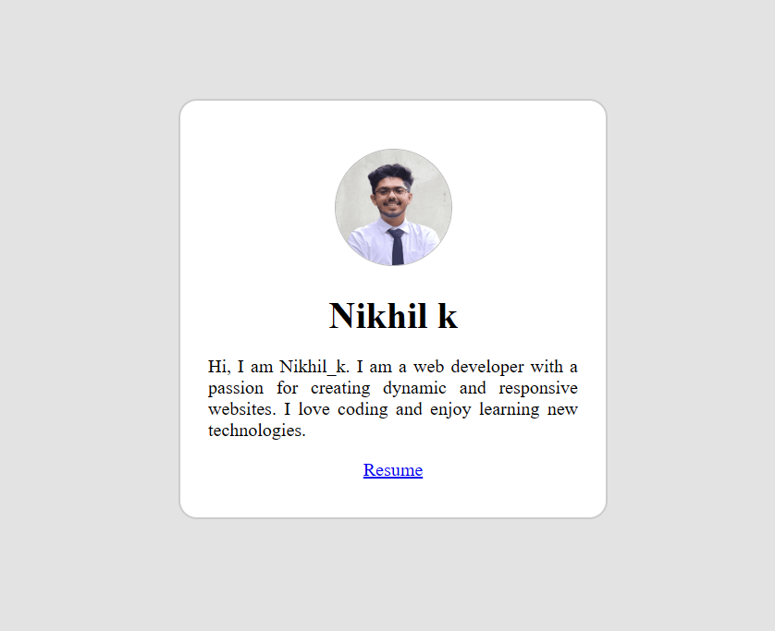

**7. Observation / Reflection**

• I learned how to combine HTML structure with external CSS for a neat profile design.

• Linking a favicon made the webpage look more polished and professional.

• This task reinforced the use of semantic tags and linking between pages.